Graphical Presentation of Data in Excel
  - Licensed under a Creative Commons Attribution-ShareAlike 4.0 International License.
The object of this lab is to learn how to create a graph in Microsoft Excel. Data from two experiments (the determination of a density and the temperature history of a liquid in a calorimeter) are to be analyzed and the data summarized in Excel spreadsheets and presented in graphs. The data and these instructions are available at christopherking.name.
Plot of Mass vs. Volume for Determination of the Density of a Liquid
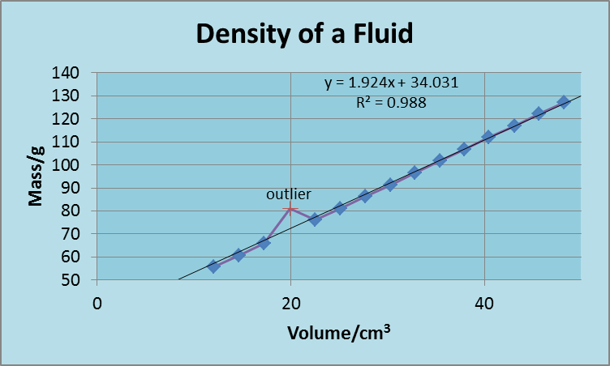
The mass of a graduated cylinder is measured after adding various volumes of a liquid. The data are plotted. It works out that the slope of such a plot is the density of the liquid. An example of such a plot is shown on the right.
To make the graph, first open the spreadsheet containing the data by going to christopherking.name, then selecting the general chemistry II lab link, and clicking on “Graphics data”. The worksheet may open on the “Enthalpy” tab. Switch to the “Density” tab by clicking on that tab at the bottom of the spreadsheet. The instructor will walk you through the following.
- Arrange this document and the Excel document side-by-side on the desktop. Here’s how to do that: Arrange windows side by side on the desktop.
- Plot the data. Select the data and column titles. (To select the data, first click somewhere in the spreadsheet to activate it, then put the mouse cursor over the starting cell, hold down the mouse button, drag the mouse to the ending cell, and release the mouse button.) On the “Insert” tab of the ribbon, in the “Charts” section, click “Scatter”, , then “scatter with straight lines and markers”, 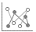. This should give a plot with mass on the vertical axis and volume on the horizontal axis.
- Label axes with both a property and units. The text for the x-axis title should be “Volume/cm3”, and for the y-axis title, “Mass/g”. (This is the new style of labeling; the old style was, e.g., “Mass (g)”.) To do this, click on the chart, then click on the icon that appears, then put a check next to “axis titles”, then click in the title to change the text.
- Superscript the 3 in cm³. Select the “3” (shift-right arrow may help select the last character in a textbox), then, with the cursor on the selection, right-click and select “font”.
- Change the font size of the axes titles to 12 and the axes numbers to 11. Click on a title to select it (if you have a blinking cursor, you are in edit mode; to select the whole title, click the edge of the title box), click on the “HOME” tab (on the ribbon), and change the font size. Do the same for the axis numbers.
- Change the title. Click in the title to change it to “Density of a Fluid”.
- Display the axis numbers as whole numbers. (If the chart “sidebar” is not visible, double click anywhere in the chart, and the sidebar will appear.) Pick an axis and click on the axis numbers, which brings up the “Format Axis” sidebar. Under “Axis Options”, click on the icon. Then, scroll down and choose “Number” at the bottom, and change the value in “Category” to “General”. Leave the sidebar open for the rest of these steps. To format the other axis all you have to do is click on the numbers on that other axis. Now, the “Format Axis” box displays the settings for that other axis, which should also be formatted as whole numbers.
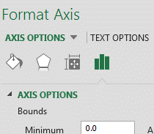
- Change the minimum and maximum of the y-axis. If the icon is not green, click on it. Under “Axis Options”, change “Minimum” to 50, and “Maximum” to 140.
- Change the spacing of numbers on an axis. While in “axis options”, change the major units to 10 for the y-axis, which also sets the spacing of the major gridlines. Then click on the x-axis and change the major units to 20 for that axis.
- Set x-axis minimum and maximum. While in “axis options”, change the minimum of the x-axis to 0 and the maximum to 50.
- Change the symbol and line properties. On the plot, click on the plot symbols or line, which will bring up the “Format Data Series” side-bar (if the side bar isn’t already showing, right-click on the line and select “Format Data Series…”). In the side-bar, click on the paint bucket icon. Click on “MARKER”, then “Marker OPTIONS”, change the marker to “built in”, and change the size to 5. The line thickness, line color, line symbol, symbol color, and plot area colors may also be changed to make the information in the chart easier to understand (personalize it; you are allowed to go crazy).
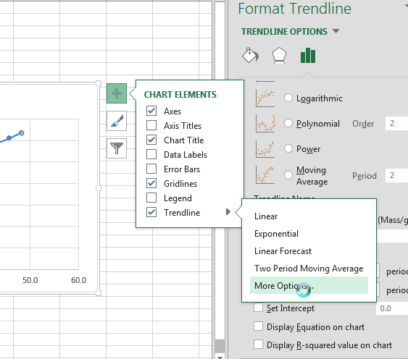
- Add a trend line. Click the icon, put a checkmark next to “Trend line”, and click on (the cursor has to be on Trend line in order for this symbol to be visible), and select “More Options…”. Click on the three vertical bars icon, and forecast forward and backward 5 “periods” (which means 5 units). Also, place a checkmark next to “Display equation on chart” and “Display R-squared value on chart”. (The slope in the displayed equation is also the density of the liquid.)
- Move the equation on the plot so that gridlines are not passing through the characters.
- Format the number of decimal places displayed in the “trend line label”. Have the equation display only 3 decimal places for each number. Click on the trendline box, in the sidebar click on the 3 vertical bars icon, change the NUMBER Category from “General” to Number”, and change the “Decimal Places:” to “3”. (You can push the “enter” key to see your changes.)
- Change a single data point. Data points that do not lie on the trend line are called outliers. Click on the one outlier twice to select it, then in the sidebar click on the paint can icon, then “MARKER”, then “MARKER”. Change “MARKER OPTIONS” to built-in, and select a marker. Change the size and marker line color.
- Add a data label to a point. With the outlier selected, click the icon, and put a check mark next to data label. Click in that label a couple of times, then change the text to “outlier”. (The outlier really should be deleted from the data to make the trend line better fit the remaining data, but let us leave the outlier in for this plot.)
When your plot is done, save the Excel spreadsheet to the desktop, and switch to the “Enthalpy” tab of the spreadsheet for the data for the next plot.
Temperature Change on Mixing an Acid and a Base
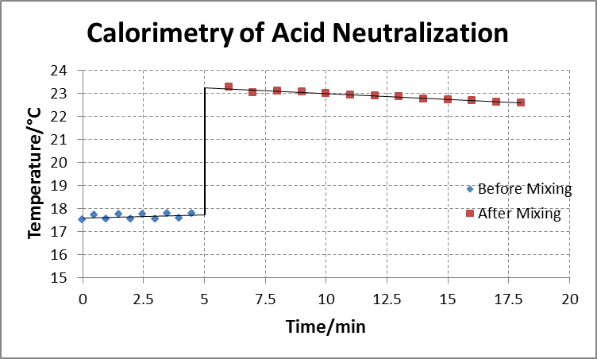
This exercise illustrates some fairly fancy features of spreadsheets. The data is from a coffee cup calorimeter experiment, in which one cup contains HCl(aq) and the other contains NaOH(aq). The temperature of the two solutions is recorded for 4 ½ minutes and is shown on the plot, below. The solution in one cup is poured into the other cup after 5 minutes. Heat is evolved, and the temperature of the reaction mixture goes up. After mixing the temperature of the mixture gradually cools off as heat is lost from the cup.
The vertical line in the plot shows the increase in temperature on mixing. That line connects the other two plots. Getting the starting and ending points for that line are a bit challenging.
The “Enthalpy” tab of the spreadsheet previously downloaded contains the data for this plot.
- Create an Excel equation to combine two data sets. The two before-mixing data sets will be combined and plotted as one data series. To do this, in cell D4, type “=” (without the quotation marks), and click on the temperature of the HCl solution at time 0.0 minutes. Press “Enter”, and that value will appear in cell D4. Below that cell, in cell D5, type “=”, and click on the temperature of the NaOH solution at time 0.5 minutes, and press “Enter”.
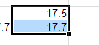
- Copy a series of Excel formulas. Rather than repeat step 1 for the next 8 cells, it is easier to copy this pair of formulas down. (If only one cell was copied, it would only give the data for HCl or NaOH, not both.) To do this, select both cells D4 and D5: click in cell D4, drag down to D5, and release the mouse button. The selection will look like what is shown on the right. Notice the square in the bottom right corner of the selection. Place the mouse over that until the cursor changes to a “+”, then drag the square down to cell D13 (where the time is 4.5 min). All of the cells will then be filled with the formula in the first two cells. All the values under HCl and NaOH should now also be in the “mixture / C” column.
- Plot the data. The data to be plotted are in columns A and D, so you can’t just select the data by dragging with the mouse. The control key lets nonadjacent cells be selected. To do the job, select cells A3 through A13, then hold down the control key while selecting cells D3 through D13. On the “Insert” tab, select “scatter chart”, and choose “scatter with only markers”.
- Add a plot title: Hint: Click the green + sign. You can copy and paste “Calorimetry of Acid Neutralization” into the title.
- Add axis titles. The x-axis title is “Time/min”; the y-axis title is “Temperature/C”.
- Add a symbol. Add a degree sign to the y-axis title, so that it become “Temperature/°C”. To enter the degree sign, place the cursor where the symbol belongs, click on the “Insert” tab of the ribbon, click on “Symbol” on the right side of the ribbon, and select the degree sign (it’s about 7 lines from the top).
- Add a trend line. Forecast forward 0.5 “periods” so that the line ends at 5.0 min (that’s when mixing takes place).
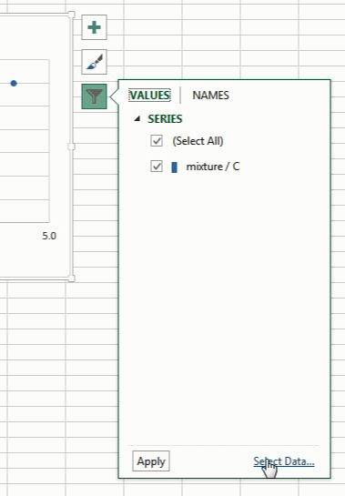
- Add a plot to the graph. To the same graph add a second plot showing the temperature after mixing. To do this, click somewhere on the graph, then click on the funnel-shaped “Chart Filters” icon, then click at the bottom on “Select Data…”. In the box that pops up, add a new series of data by clicking on the “Add” button, and, in the “Series name:” box enter “After Mixing”. Enter the time values by clicking on the button on the right side of the “Series X values:” box, and selecting the times from 6.0 to 18.0 min, then press enter. Likewise, enter the temperature values by clicking on the button next to the “Series Y values:”, and selecting the temperatures corresponding to the selected times. Click on the OK button. And, again, click the OK button.
- Add a trend line, forecasting backward 1.0 period, which is when mixing took place.
- Set the y-axis minimum to 15°C.
- Display the y-axis numbers as whole numbers, as done with the previous graph. (Leave the decimal in the x-axis numbers.)
- Change the line marker to built-in (pick any symbol you like) and change the size to 4 on both plots.
- Change the name of the first series from “mixture/C” to “Before Mixing” (use the funnel icon).
- Make all gridlines dashed. Click the icon, click the after gridlines, and select “More Options…”. The sidebar shows “Format Major Gridlines”, and, below that, “major gridline options ”, below that, “Line”. Change the “Dash type” to display some sort of dashed line. To change the other set of gridlines, click on the shown after “major gridline options”, and select the “Horizontal Axis Major Gridlines”.
- Display vertical gridlines every 2.5 minutes. Click on the “Time” axis numbers, then on the three vertical bars icon, then on “Axis Options”, and change the “Units” “Major” to 2.5. Press enter, or click in another box to get the display to update.
The next task is to add the vertical line to the graph at 5.0 minutes. One end of that line is at the end of the “before mixing” trend line; the other end is at the start of the “after mixing” trend line. The ends of the trend lines at 5.0 min will be calculated using the equation of a straight line, y = mx + b, with x equal to 5.0. The slope and y-intercept will be determined using the “linest” function in Excel. This function uses an advanced technique in Excel called an array formula, which is a formula that gives results in more than one cell. Array formulas are completed not by just pressing “Enter”, but by holding down “Ctrl” and “Shift” while pressing “Enter”.
- Move the graph. Move it so it isn’t covering up any of the text or numbers on the worksheet, so you will have room to work with the data.
- Calculate the slope and y-intercept before mixing. Select cells G6 and H6, which are underneath the headings “slope” and “y-intercept”, and next to “before mixing”. Type “=” and “linest(”. A tooltip appears, showing what values this function requires. The first is “known _y’s”, so select cells D4 through D13, then type a comma, then select the “known_x’s” by selecting cells A4 through A13. The other parameters for this function are optional and not needed, so just enter a closing parenthesis, and hold down “Ctrl” and “Shift”, then press “Enter”. The array formula worked if it is now surrounded by brackets, {…}. The brackets don’t get entered from the keyboard; they appear after Ctrl-Shift-Enter is pressed. Now, cell G6 contains the slope and cell H6 contains the y-intercept of the “before mixing” trend line.
- Calculate the slope and y-intercept after mixing. Likewise, determine the slope and y-intercept after mixing.
- Enter the x values for the vertical line. The vertical line occurs at a time of “5”, so enter “5” in both cells G11 and G12, under the “x”.
- Calculate a y value for the vertical line using y = mx+b. To do this, click in cell H11, type “=”, click on the slope before mixing (cell G6), enter the multiply symbol, which is an asterisk, *, click on the x value before mixing (the first 5), type “+”, click on the y-intercept before mixing, and press enter.
- Calculate the second y value. Copy the previous entry (cell H11) to the cell below it (H12). The formula now uses the “after” values.
- Add the vertical line to the graph. Click on the graph, click on the funnel, and click on “Select data”. Add a data series named “Mixing” that contains the two (x, y) points you’ve just created. The graph will be hard to see because it only has symbols at the ends.
- Format the vertical line. Select the new plot on the graph in the sidebar by clicking on the top heading with next to it, and select Series “Mixing”. Add a thick line to the plot, and remove the markers from the plot.
- Add a legend. Click on , select “Legend”. Click on the at the end of Legend, select “More Options…”. On the sidebar under “Legend Options”, click on the icon. Under “Legend Options”, “Position”, uncheck the box that says “Show the legend without overlapping the chart”.
- Remove the trend lines from the legend by clicking on each one in the legend and pressing delete.
Save the Excel file on the desktop and email (by going to login.microsoftonline.com) a copy of it to the instructor. Please include your name in the body of the email, and Excel Lab in the subject line. Verify that you have a copy of the sent email, then please delete the file from the desktop, so the next group can start with a clean desktop.
Recommended reading: Tufte, Edward R (2001) [1983], The Visual Display of Quantitative Information (2nd ed.), Cheshire, CT: Graphics Press, ISBN 0-9613921-4-2

