# Molar Mass by Freezing Point Depression

Troy University Chemistry Faculty

[Creative Commons License](http://creativecommons.org/licenses/by-sa/4.0/) Licensed under a [Creative Commons Attribution-ShareAlike 4.0 International License](http://creativecommons.org/licenses/by-sa/4.0/).

## Objectives

To observe freezing point depression

To use freezing point depression to determine how many moles of solute are in a solution.

To use mass and moles of a substance to determine its molar mass.

## Introduction

To make home-made ice cream, the ice cream ingredients must get colder than 0 °C. This is achieved by placing the container of ingredients into ice that is sprinkled with lots of salt. The salt lowers the freezing point of the ice, so that the ice-salt water mixture is colder than 0 °C. This lowering of the freezing point of a solvent (water) when a solute (salt) is added is called *freezing point depression*, which is represented by Δ*T*f. This Δ*T*f, is the difference between the freezing point of the pure solvent and of the solution (for example, water and salt water). The amount by which the freezing point is lowered depends on the how many solute particles present, but not on their identity. So, a mole of NaCl would lower the freezing point by about the same amountas would a mole of KBr. The relation between number of particles and Δ*T*f is given by

ΔTf = *k*f *m*. Eq ()

In this equation *k*f is a constant called the “freezing point depression constant”, which only depends on the solvent; every solvent has its own value of *k*f. The *m* is a measure of concentration, called the “molality” of the solution. Whereas molarity, *M*, is $\frac{moles of solute}{liters of solution}$, molality, *m*, is $\frac{moles of solute}{kilograms of solvent}$. The two differences between molarity and molality are both in the denominator: one has units of liters, the other kilograms; and one refers to the solution, the other to the solvent.

Figure 1. **Cooling curve, from Wikipedia, Courbe analyse thermique generique.svg**

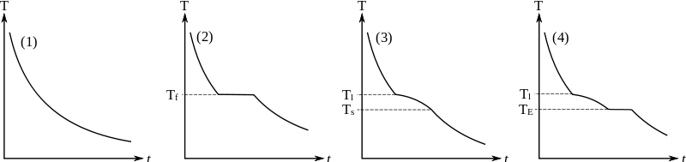

The freezing point will be determined by creating a plot called a cooling curve, Figure 2. In this plot, a solution is cooled down and the temperature is recorded as a function of time. When the solution reaches the freezing point, the temperature stays constant until all of the liquid has frozen, then the temperature drops again, as the solid cools. Figure 2 shows a 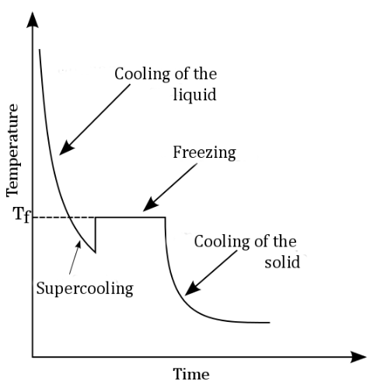liquid supercooling before freezing. In a very clean test tube, the solid has no place to start to form, and the solution can get colder than the freezing point, but then solid begins to form, and the temperature returns to the freezing point.

To determine freezing point depression, the freezing points of a pure solvent is determined, then a solute is added and the freezing point is determined again. The difference between these temperatures is the freezing point depression, Figure 3.

Figure 2**. Plot of a liquid freezing showing supercooling. From Wikipedia: “Cooling curve showing supercooling.png”.**

Freezing point depression can be used to determine the molality of a solution, from which the molar mass of a substance can be determined. The molar mass of a known quantity of a pure substance can be calculated by the following:

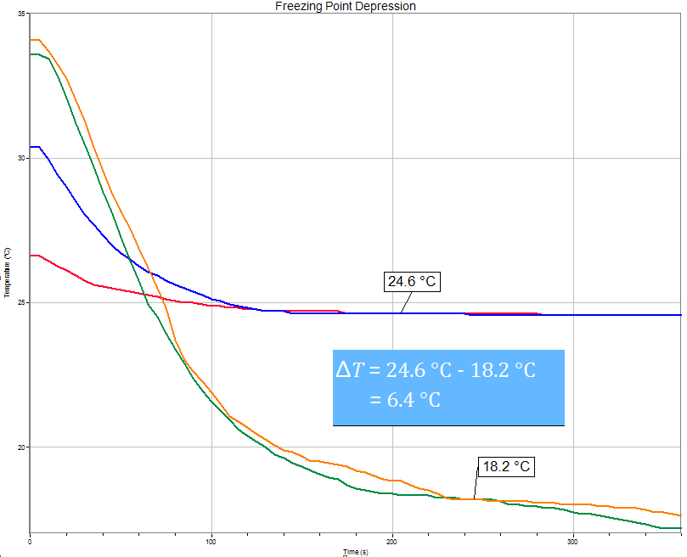 Eq ()

The mass is easily determined with a balance, but the number of moles is more difficult to determine. First, molality is determined from the freezing point depression. Simply solve eq(1) for molality:

Eq ()

The value of *k*f is given in the procedure, and Δ*T*f will be measured, allowing the molality to be determined. Then, using that molality, the number of moles of solute can be determined: since molality has units of mol/kg, just multiply molality by the mass of solvent in kg (which is measured using a balance:

Figure 3. **Freezing point depression. (Graph from logger pro). Two of the runs are for the pure solvent (freezing point about 24.8 °C. The other two are for the solvent to which an unknown has been added (freezing point about 18.2 °C). The difference between these is the freezing point depression, Δ*T*f.**

Eq ()

This may be clearer if *m* is replaced with its units:

Eq ()

Finally, this number of moles of solute is substituted into Eq (2), allowing the molar mass to be calculated.

**Example** Cyclohexanol is an organic solvent that has a value of *k*f of 39.3 °C kg/mol, which is a fairly large value. (A large value is convenient, because the larger the value of *k*f, the larger the freezing point depression, which makes it easier to measure.) Suppose that a test tube is filled one-third full with cyclohexanol, and is found to contain 35.5 g of that solvent. The freezing point of the pure solvent is determined by placing the test tube in a cold water bath and measuring the temperature at which the solvent appears to freeze, which is found to be 25.0 °C. Now the solvent is thawed and 4.1 g of a solute is added to the solvent. (The molar mass of the solute is to be determined.) The freezing point of the solution is measured and found to be 17.4 °C. The molality of the solution is found to be

Eq ()

The number of moles of solute present is given by the following (the term in parentheses is the molality, with its units included).

Eq ()

= 0.193 mol/kg × 0.0335 kg = 0.00685 mol

(Note that the mass of solvent had to be converted from grams to kilograms.) The molar mass of the solute is found as follows:

Eq ()

## Procedure

This lab uses *t*-butyl alcohol, whose structure is shown on the right. Alcohols have an –OH group attached to a carbon; “butyl” means something containing four carbons; the “*t*” stands for tertiary, because the central carbon is attached to three other carbons. This alcohol is very soluble in water, so if you get it on your hands just rinse it off with water. The melting point of this alcohol is rather high, so it is usually a solid at room temperature, and has to be melted before it can be used. The value of ***k*f for *t*-butyl alcohol is 8.37 °C kg/mol**.



### Prepare a test tube containing a known mass of solvent

Obtain a clean, dry, large test tube (the slightest bit of water in the tube will lower the freezing point of the alcohol considerably). Record the mass of the empty test tube to the nearest hundredth of a gram (the balance that weighs to the thousandth of a gram could also be used). The contents of two bottles of *t*-butyl alcohol have been melted by leaving them in a 50 °C water bath overnight. Pour 25 mL of the alcohol into the large test tube. A graduated cylinder is inconvenient for this, because the liquid may solidify in the graduated cylinder, especially in a cold room. Instead, just pour the alcohol into the test tube to the same level as a tube containing 25 mL of water (this tube should be near the bottles of alcohol). Record the mass of the test tube with the alcohol in it.

How to weigh a test tube 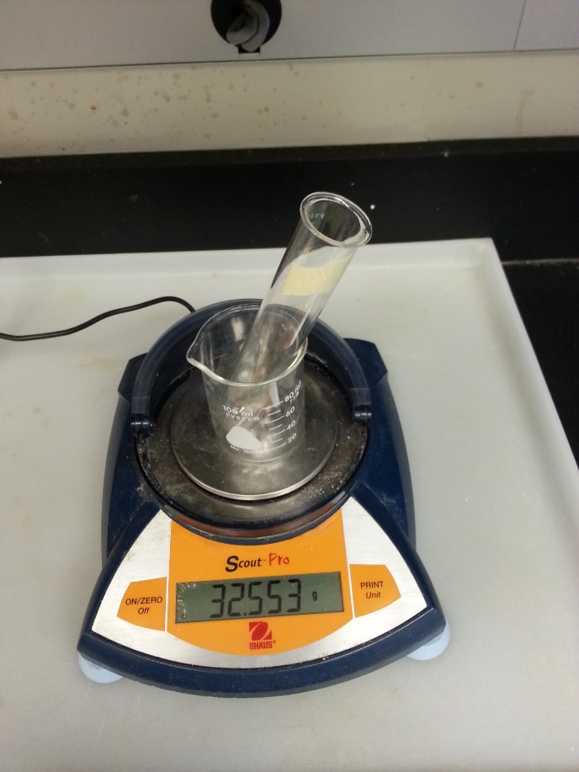with liquid in it? Tare a 100 mL beaker, place the test tube with solvent in that beaker to hold the tube upright, and record the mass. A 150 mL beaker weighs too much and will overload some of the balances).

### Set up the Software

1. Plug the USB end of the temperature probe into the computer.
2. Start the software by clicking on the “Logger Pro” icon, , on the desktop. If the software is already running, click the “New” icon, , to reset the program (try this if the software doesn’t seem to respond).
3. Setup the software for data collection.
4. On the Main screen, click the “Data collection” icon, .
5. Set the “Duration” to “360” seconds.
6. Set the “seconds/sample” to “0.5” (note that this will automatically update the other field, “sample/second”).
7. Click “Done” to return to the Main screen.

### Part I. Determine the Freezing Temperature of Pure t-Butanol

1. 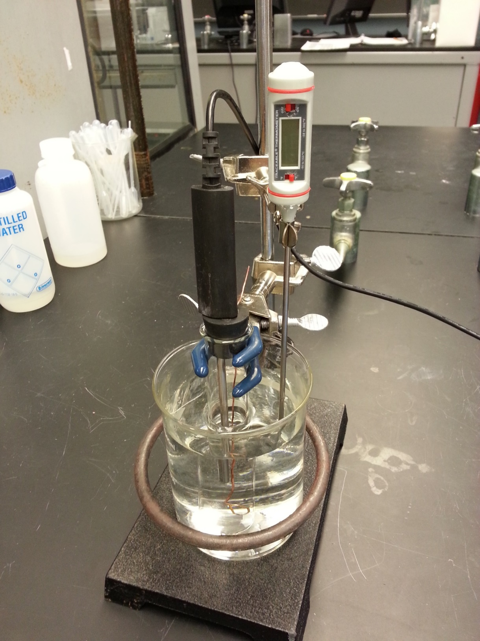Fill a 600 mL beaker with about 400 mL of water. Add some ice and mix until the temperature is about 10-15 °C. Place the stopper with mixing wire and temperature probe into the test tube containing the alcohol (the loop-end of the mixing wire goes into the liquid). Clamp the test tube assembly to the ring stand above the beaker (don’t lower the test tube into the water bath, yet). Warm the solvent in the test tube up to about 30 °C using the hair dryer.
2. Lower the test tube assembly into the water bath so that the liquid level in the test tube is slightly below the water level outside the test tube (so that all of the alcohol will be at the same temperature).

*Note: if the tip of the temperature probe is touching the bottom or side of the test tube, the temperature won’t be that of the liquid.*

Click to start data collection. The “Collect” icon will change to the “Stop” icon, . (If the software is not responding, close the program and restart it.) Constantly mix the solution by moving the metal wire up and down until the alcohol is completely frozen, or until data collection stops (it will stop automatically after 6 min).

Mixing keeps the temperature the same throughout the solution, and considerably improves the appearance of the cooling curve.

1. The freezing temperature can be determined by finding the mean (i.e., average) temperature in the portion of the graph with nearly constant temperature.

Expand the graph by clicking on the “Autoscale Graph” icon, .

With the mouse select (click and drag the mouse) the region with nearly constant temperature. That region will then appear in gray. Click the “Statistics” icon, . Record the mean (average) temperature of this region as the freezing temperature of pure *t*-butanol.

1. Do a second run.

First, warm the test tube with a hair dryer to melt the *t*-butanol and raise its temperature to at least 30°C.

1. Second, click collect, , to start data collection. The software will ask if the last run should be kept; click “Store latest run”, because both runs should be on the graph.
2. Have the instructor approve your work so far. Do not discard your *t*-butyl alcohol; save that solvent for the next part. Also, do not close Logger Pro.

Average the two freezing point measurements and record this mean freezing point on the data sheet.

### Part II. Determine the Freezing Temperature of a Mixture of t-Butanol and an Unknown

1. Weigh out about 2 grams of a solid unknown on weighing paper and record the mass actually weighed out. Add it to the test tube of alcohol, above (warm the tube if the alcohol is still frozen). Make sure the unknown completely dissolves. The water bath should be about 10 °C, since the freezing point will be lowered. Record the cooling curve as previously done with the pure solvent.
2. Estimate the freezing point of the mixture. Unlike pure *t*-butanol, the temperature of the mixture may gradually decrease during freezing. So, DO NOT use the average function. Instead, the freezing point is taken to be the temperature at which the mixture initially started to freeze. To estimate that temperature, click on the “Examine” icon, . As the cursor is moved over the graph, the temperature and time values are displayed in a box on the graph. Locate the initial freezing temperature of the solution, as shown above in Figure 3, and record that as the freezing temperature in your data table.
3. Warm the mixture up about 10 °C above its current melting point and record the cooling curve one more time.
4. Print the graph, which should now have four cooling curves on the same plot.
5. Calculate the freezing point depression for each run. Use the mean freezing point for the pure solvent.
6. Calculate the molality of each solution; see equations (3) and (6). Use the value of *k*f for t-butyl alcohol, which is 8.37 °C kg/mol.
7. Calculate the number of moles of the unknown; see equations (4) and (7)
8. Calculate the molar mass of the unknown; see equations (2) and (8).
9. Ask the instructor for the actual molar mass. Calculate the percent error.