# Spontaneity and Reversal of Reactions

Troy University Chemistry Faculty

[Creative Commons License](http://creativecommons.org/licenses/by-sa/4.0/) Licensed under a [Creative Commons Attribution-ShareAlike 4.0 International License](http://creativecommons.org/licenses/by-sa/4.0/).

## Objective

1. Distinguish spontaneous and non-spontaneous reactions.
2. Demonstrate that a non-spontaneous reaction can be made to take place if work is done on the reaction system.

## Introduction

A spontaneous reaction is one that takes place without any work having to be done. For example, manganese metal will spontaneously react with nickel(II) ion:

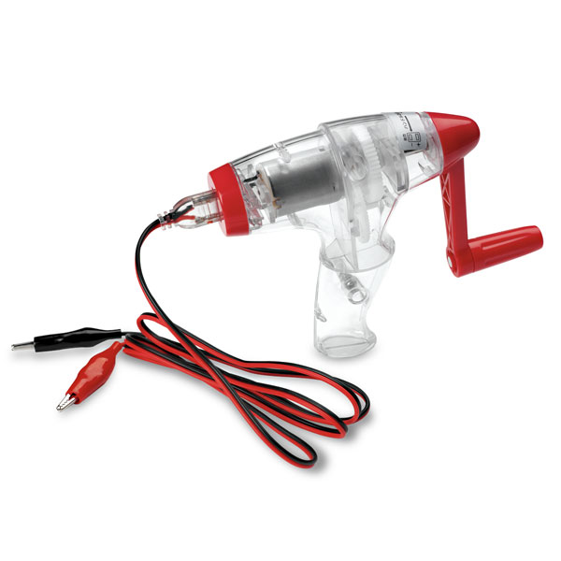 Mn(s) + Ni(NO3)2(aq) → Mn(NO3)2(aq) + Ni(s)

Some spontaneous reactions can be made to go backwards by doing work. This lab uses a hand-held DC generator (Figure 1) to do the work. When the crank is turned, electricity is produced. Electricity can, of course, do work; this electrical work can cause a reaction to go in the opposite direction:

Work + Mn(NO3)2(aq) + Ni(s) → Mn(s) + Ni(NO3)2(aq)

Figure . Genecon DC generator. The device is hand held. When the crank on is turned, the generator will produce a small electric current, creating an electrical potential of up to a 12 volts. (Source: NADA Scientific, Ltd)

The chemical changes taking place are easier to see if these reactions are written as net ionic equations. (You are asked to write some of those for this lab.) Reminder: in a net ionic equation, all aqueous species are written with the ions separated; all phases are shown, and charges are given for all ions. The ionic equation for the spontaneous reaction above is:

Mn(s) + Ni2+(aq) + 2NO3–(aq) → Mn2+(aq) + 2NO3– (aq) + Ni(s)

Cancelling the spectator ions gives

Mn(s) + Ni2+(aq) → Mn2+(aq) + Ni(s)

A net ionic equation for the non-spontaneous reaction can written as

Work + Mn2+(aq) + Ni(s) → Mn(s) + Ni2+(aq)

## Procedure

Suppose that two compounds, A and B, spontaneously react to form C and D.

A + B → C + D

Now, consider what would happen if C and D were mixed. Because the reaction goes spontaneously from left to right; the reverse reaction will not spontaneously occur, so if C and D are mixed, nothing will happen, so they must be the products of the reaction.

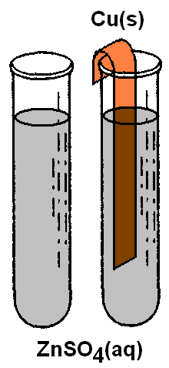The object of the next two experiments is to determine which pair of compounds is reactants, and which pair is products for a spontaneous reaction. Using that information, you can then write a net ionic equation for the reaction that is spontaneous.

### Equipment Check

Connect the light bulb to the hand-cranked generator by connecting the alligator clips from generator’s leads to the alligator clips on the light bulb. (It does not matter which color lead is connected to which.) Turn the generator crank, and confirm that the light bulb lights up. If it doesn’t, the instructor can provide a replacement bulb.

### A Spontaneous Reaction

In some of the following reactions a black powder will appear on an electrode. The black powder is tiny particles of the element. Although in large amounts copper and zinc are not black, as very tiny particles, these metals may appear as a black powder.

#### Adding Cu(s) to ZnSO4(aq)

Figure . CuSO4(aq) solution in test tube (left) and tube after inserting a Zn(s) strip.

Figure . ZnSO4(aq) solution in test tube (left) and tube after inserting a Cu(s) strip (right).

Picture1Fill a test tube with ZnSO4(aq) solution, and place the tube in a test tube rack. Bend a strip of Cu(s) metal into a hook shape and place it in the solution, as shown in Figure 2. After a short time—20 seconds is sufficient—remove the copper strip, examine it, and record your observations in Table 1. Be sure to note any color changes in the Cu(s) strip or in the solution. Does it appear that a chemical reaction has spontaneously occurred?

Note that, since sulfate has a 2– charge, the charge on zinc in ZnSO4 is Zn2+. This is the only commonly found charge on zinc ions, so, if Zn is present as an ion, it will have a 2+ charge.

#### Adding Zn(s) to CuSO4(aq)

Fill a test tube with CuSO4(aq) solution, and place the tube in a test tube rack. Bend a strip of Zn(s) metal into a hook shape and place it in the solution, as shown in Figure 3. After a short time—20 seconds is sufficient—remove the zinc strip, examine it, and record your observations in Table 1. Be sure to note any color changes in the Cu(s) strip or in the solution. Does it appear that a chemical reaction has spontaneously occurred?

Write a balanced net ionic reaction for the spontaneous reaction involving the four substances used above.

### A Non-spontaneous Reaction

#### Sensation of Doing Work

In the following sections, we are going to sense the work we do with the generator and make the non-spontaneous reaction take place by doing work on the system.

The ease of turning the generator crank depends on how much work the generator is doing. A qualitative comparison of the amount of work required to turn the crank will be made under the following conditions:

* 1. with nothing connected (load-free).
  2. with a 6 V light bulb connected to the leads.
  3. with the leads connected to power an electrochemical process (the reaction of Zn(s) and Cu+2(aq)).

##### Generator under No Load

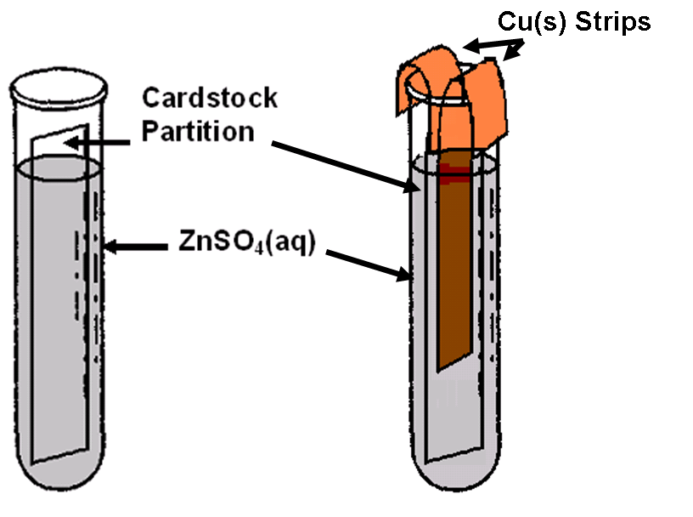Obtain a hand cranked DC generator. To test the frictional resistance of the generator, separate the alligator clip ends of the wires that are plugged into the generator. Make sure the clips are not touching one another, and turn the generator crank in a clockwise direction. Note the resistance the generator offers to your turning the crank, and record your impression of this level of resistance under the “Task 1” row in the “Load Level” column of Table 2.

##### Generator Loaded with a Light Bulb

Attach the alligator clips on the end of the leads from the generator to the leads attached to a flashlight light bulb. Turn the generator crank clockwise until the light bulb filament starts to glow. Continue turning the generator crank until you have a firmly established sensation of how hard it is to turn the crank. This assessment gives you an impression of the work needed to keep a small light bulb lighted. Record your impressions of the level of work required for this task under “Task 2” in Table 2.

Figure . Test tube containing ZnSO4(aq) and two strips of Cu(s). A strip of cardstock divides the test tube into two separate chambers. Each chamber contains a Cu(s) strip.

##### Generator Loaded with Chemical Reaction

Prepare a test tube as shown below. Use a large test tube, and partition it into two chambers with a strip of cardstock paper cut to size. (The cardstock is on the front desk of the lab.) Fill the test tube to within 1 cm to 2 cm of the top of the tube with a solution of ZnSO4 (the previous ZnSO4 solution may be used here). Place the tube in a test tube rack. It should resemble the left portion of Figure 4. The right portion of the figure shows the test tube after the two copper strips have been inserted into the two respective partitions that the cardstock creates in the test tube.

The cardstock serves to keep the two copper strips separated and prevents a short circuit that their contact would create. Make sure that the two Cu(s) strips are **completely separated** during the following process***.***

Attach the generator’s lead’s alligator clips to each of the Cu(s) strips in the test tube illustrated above. Then turn the crank of the generator in a clockwise direction. Note the force the new load has created for the power source (you!) driving the generator and record your observation concerning the load in “Task 3” of Table 2. Also record any noticeable color changes on either of the strips and in the solution. Continue turning the crank (always clockwise) until you are certain that any chemical change that will occur does occur… this may take up to two minutes.

Disconnect the generator leads from the copper strips. Next, adjust the voltmeter to display voltage in volts. This is done by setting the maximum voltage the meter will experience; a setting of 20 DCV (direct current volts) will do the job. The voltmeter electrode tips are metallic; if they are not visible, remove their plastic covers. Press the two voltmeter electrodes down onto the two copper strips (this is easiest to do if the electrodes press each strip down onto the glass lip of the test tube). Record the voltage (it will fluctuate a bit) and your observations in “Task 4” of Table 2. Switch the voltmeter electrodes. What happens to the reading? What is another name for this apparatus? (Hint: it is portable, and is used in cell phones.)

### Electrode Cleanup

The Cu(s) strips need to be cleaned for use in other lab sections. To clean them, obtain a large test tube, fill it to within 2-4 cm of the top with 1 *M* HCl(aq). Place the Cu(s) electrodes in the HCl. Note any visible reaction that takes place in Table 3. This reaction may take a few moments to begin.

When the reaction appears to be complete, pour the acid and the Cu(s) into a 150 ml beaker, remove the Cu(s) with tongs, and rinse the Cu(s) well under tap water. Return the Cu(s) to your desk area, and discard the acid in the spent acid disposal container provided. (All waste for General Chemistry II Lab goes in the hood behind the hood at the front of the room.)

Remove the black on the zinc by just wiping with a paper towel. Record in Table 3 what the material on the Cu and Zn electrodes is most likely to be.

Turn in just the data sheets. Although you may work in pairs, each student should turn in a data sheet.